Ideation Phase

Define the Problem Statements

|  |  |
| --- | --- |
| Date | 1-November-2022 |
| Team ID | PNT2022TMID18166 |
| Project Name | Project – Analytics For Hospital Health-Care  Data |
| Maximum Marks | 2 Marks |

Reference: <https://miro.com/templates/customer-problem-statement/>

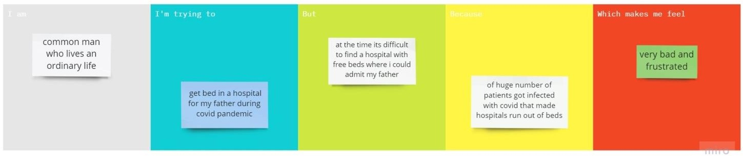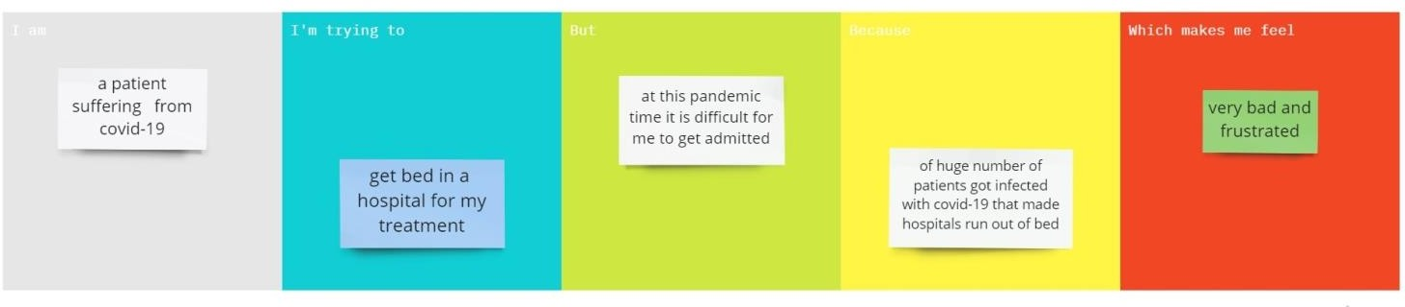**Example:**

|  |  |  |  |  |  |
| --- | --- | --- | --- | --- | --- |
| **Problem Statement**  **(PS)** | **Iam (Customer)** | **I’m trying to** | **But** | **Because** | **Which makes me feel** |
| PS-1 | common man who lives an ordinary life | get bed in a hospital for my father during covid-19 pandemic | at the time its difficult to find a hospital with free beds where i could  admit my father | of huge number of patients got infected with covid-19 that  made hospitals run out of beds | very bad and frustrated |
| PS-2 | a patient suffering from covid-19 | get bed in a hospital for my treatment | at this pandemic time it is difficult for me to get admitted | of huge number of patients got infected with covid-19 that  made hospitals run out of beds | very bad and frustrated |